 |  | 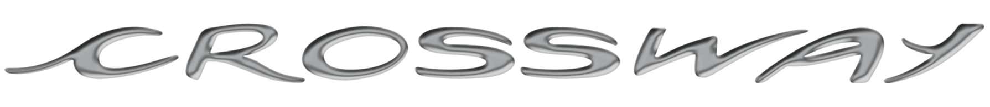
 |  | INTERCITY COACH – 12m / 12.80m
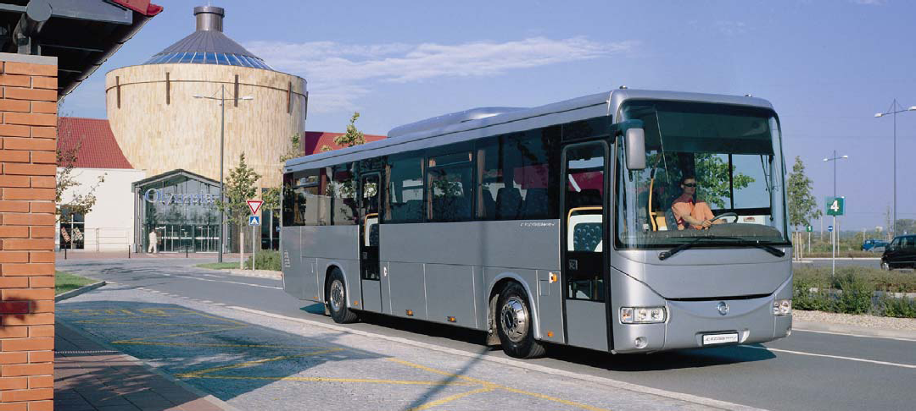

 | 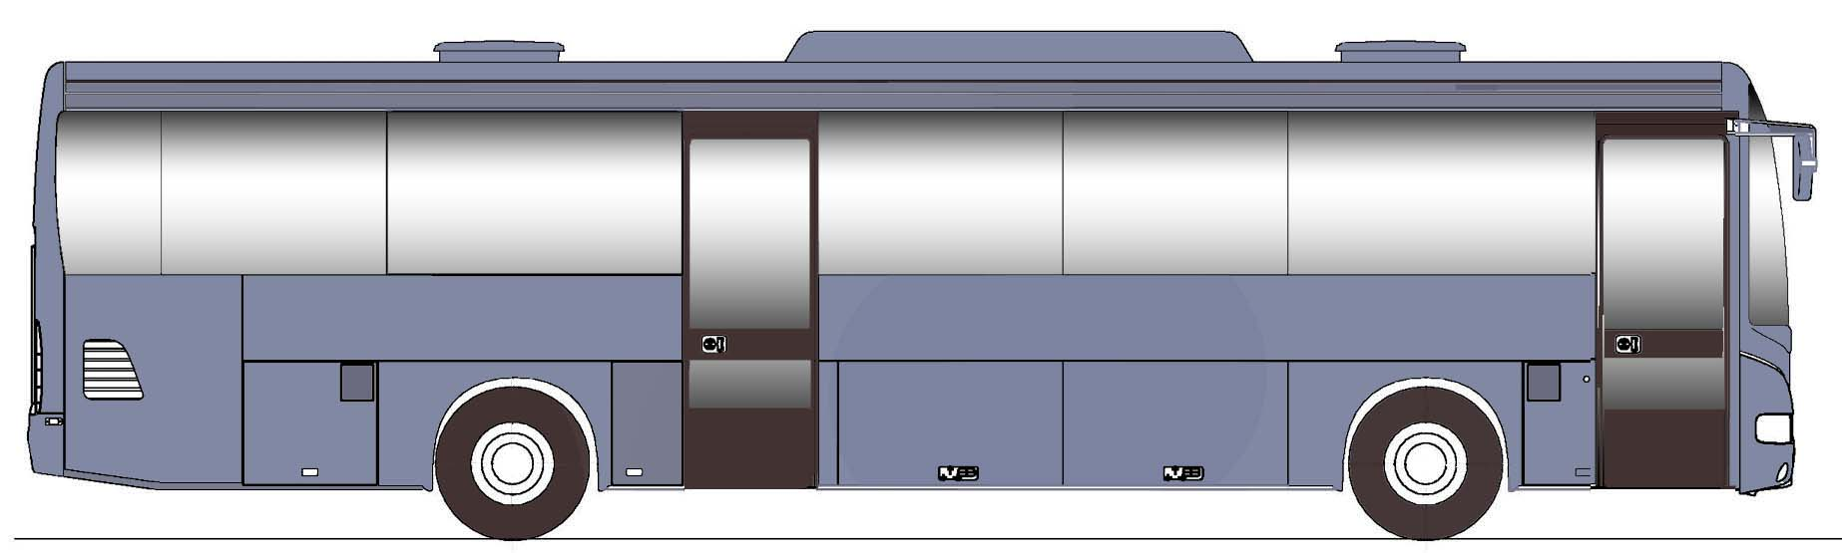  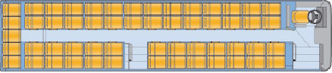 |  |  |  |  |  | GENERAL FEATURES
 |  |  |  |  |  |  | Length |  | 11 995 mm |  |  |  | 12 760 mm
 |  |  |  |  |  |  | Width |  | 2 550 mm
 |  |  |  |  |  |  | Height with / without A/C |  | 3 455/3300 mm
 |  |  |  |  |  |  | Wheelbase |  | 6 200 mm |  |  | 6 965 mm
 |  |  |  |  |  |  | Front / rear overhang |  | 2 503 / 3 292 mm
 |  |  |  |  |  |  | Interior height clearance in the corridor |  | 2 275 mm
 |  |  |  |  |  |  | Floor height |  | 860 mm
 |  |  |  |  |  |  | Access height of front / centre doors |  | 344 / 344 mm
 | Layout maxi 12 m : 55 passenger seats (2001/85) |  |  |  |  |  | Width of front / centre doors* |  | 800 / 800 mm
 | 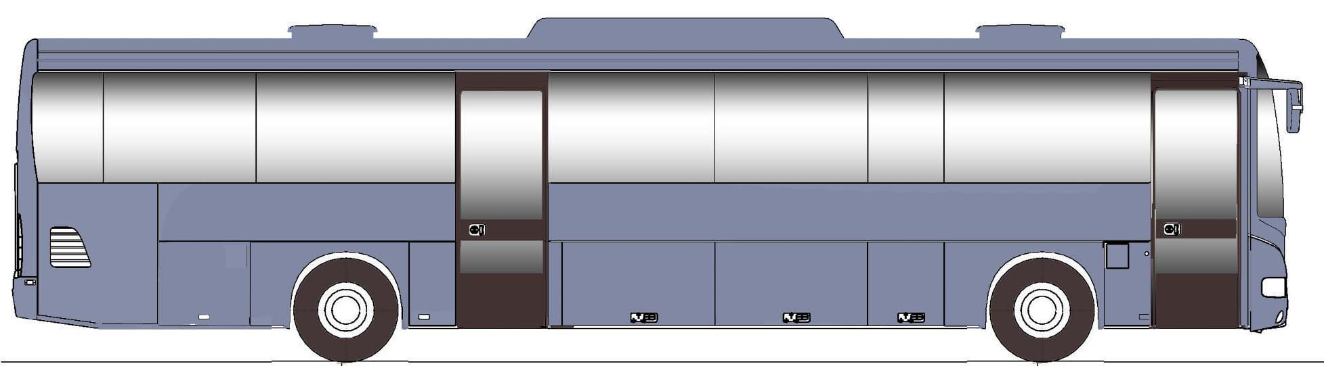 |  |  |  |  |  | Kerb-to-kerb turning radius |  | 9 400 mm |  |  |  | 10 150 mm
 | 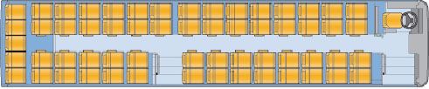 |  |  |  |  |  | Wall-to-wall turning radius |  | 11 050 mm |  |  |  | 11 650 mm
 |  |  |  |  |  |  | Angle of attack / escape |  | 8°/8°
 |  |  |  |  |  |  | Maximum permitted weight on rear axle* |  | 11 500 kg
 |  |  |  |  |  |  | Maximum permitted weight on front axle |  | 7 100 kg
 |  |  |  |  |  |  | G.V.W.* |  | 18.000 kg
 |  |  |  |  |  |  | Capacity of the interior luggage compartment |  | 2.8 m³ |  | 3 m³
 |  |  |  |  |  |  | Capacity of the luggage |  | 5.7 m³ |  | 6.7 m³
 | Layout maxi 12.80 m : 59 passenger seats (2001/85) |  |  |  |  |  | * depends on local regulation and equipment of the vehicle
 |  |  |  |  |  |  |  |   194 kW (264 Hp)  220 kW (300 Hp)  243 kW (330Hp)  280 kW (380Hp) |  | Euro 5  EEV

CROSSWAY | 12m / 12.80m
 BODYWORK / EXTERIOR EQUIPMENT  Anticorrosion treatment by cataphoretic immersion, finished with a polyurethane resin final coat  Exterior front and middle clearance door width 670 mm  Side luggage compartment doors in pressed aluminum  Optional*:  Middle clearance door width 1200 mm  Painting customization  Labels "Transport of children"  Upper rear light (direction & brake lights)   INTERIOR EQUIPMENT  Floor covered in self-adhesive anti-slip PVC  Luggage racks above passenger seats  Side walls in laminated panels  Roof trim in laminated panels  Dividing walls trimmed in laminate  Automatic lighting of driver's compartment when doors are open  2 roof-mounted handrails  Optional*:  Central platform  Wheelchair ramp with space to accommodate one wheelchair user  (with middle door 1200 mm wide)  Full height dividing wall behind the driver  Curtains on side windows and rear glass  Refrigerator integrated in the dashboard  Request buttons to "STOP"  RADIO / VIDEO  Optional*:  Preparation for radio  Complete installation for RADIO/CD  Complete installation for VIDEO  Microphone for driver   ELECTRICAL EQUIPMENT  2 batteries 12 V - 170 Ah, mounted on a tray  2 alternators, 2 x 90 A  Electrical box with fuses in the front left storage compartment  Incandescent lighting of passenger compartment  Fire detection system  Optional*:  24 V socket on instrument panel  Protection by thermal circuit breakers  230 A/h batteries  140 + 80 A Alternators  Hazard warning lights activated when doors are opened  Lighting in luggage compartment  Reversing sensor system  Lighting panels with neon tubes  Front fog lamps   WINDOWS / THERMAL COMFORT  Tinted simple glass all round without ventilations  4 emergency exit windows ; 2 left and 2 right  - opaque roof hatches  Thermal side, front panel & roof insulation  Heating for passengers by 4 heaters  Air extractor in the rear  Electrical demisting of the front door  Optional*:  Side windows with tilting or sliding ventilations  Double glazing of side windows; front door; driver’s side window  Air conditioning without reheating function (roof unit)  Air conditioning with reheating function (roof unit)  Independent heating 30 kW  4 heaters for passengers with channels  Demisting of front steps   DRIVING POSITION  Fully adjustable driver's air suspension seat with headrest, with 3 point seat belt  Storage tray in central and side console  Side/ front sun visor manually operated  Exterior temperature indicator  Engine rev counter  Digital tachograph  On-board computer (steering wheel controls) with fuel consumption control  Optional*:  Driver and passenger seats in same trim  Driver luggage compartment rack with lock  Hostess seat with 3 point safety belt  2 bottles refrigerated storage container  Front sun visor electrically operated  Alcohol Tester |  |  |  ENGINE  IVECO TECTOR EURO EEV diesel with 6 cylinders in line.  Maximum power 194 kW (264 HP) at 2 200 – 2 500 rpm  Maximum torque 1 000 Nm at 1 400 rpm  Engine capacity 5.9 litres  Cooling of the inlet air by air-air intercooler  Electronic regulation  Hydrostatic fan  Cold start by means of a resistor integrated into the induction manifold  Electric accelerator  Optional*:  IVECO TECTOR EEV with enhanced power  Maximum power 220 kW (300 HP) at 2 300 – 2 500 rpm  Maximum torque 1 050 Nm at 1 250 – 1 850 rpm  IVECO CURSOR 8 EURO 5 diesel 6 cylinders in line ; 7.8 liters  Maximum power 243 kW (330 HP) at 1 550 – 2 050 rpm  Maximum torque 1 500 Nm at 1 125-1 550 rpm  IVECO CURSOR 8 EURO 5 (SCR system)  Maximum power 280 kW (380 HP) at 2 050 rpm  Maximum torque 1 500 Nm at 1 125-1 550 rpm  EEV (environmentally enhanced vehicle) exhaust emission standard   GEARBOX  6 speed mechanical gearbox ZF  Exterior warning buzzer with the shift of reverse speed  Optional*:  Automatic 4 speed VOITH D864.5  Automatic 6 speed ZF 6 HP or AsTronic   DRIVE AXLE  STANDARD axle ratio 5,29 (max speed 116 km/h)  Single reduction rear axle  Optional*:  Other ratios available (please contact us)   FRONT AXLE / STEERING  Front axle with independent wheels suspension  Hydraulic steering ZF  SUSPENSION  Full air suspension with self-leveling sensor  Front: 2 air springs /2 shock absorbers / 1 stabilization bar /1 leveling sensor  Rear: 4 air springs/ 4 shock absorbers / 4 retaining rods /1 stabilization bar / 2 leveling sensors  Optional*:  Lifting / Lowering device of the vehicle suspension   COMPRESSED AIR  Dual cylinder air compressor 630 cm3 (pressure 9,5 bar)  Integrated air dryer: Bleeding valves on the air tanks   BRAKES  Pneumatically-controlled service disc brakes in front and rear  ABS (anti block system)  ASR (anti-slip system)  Parking brake: 2 cylinders  Emergency brake : guaranteed by independent circuits  Optional*:  Vehicle immobilization when the front or middle doors are open  Electronic control of vehicle stability (ESP)  Electronic control of brakes (EBS)   RETARDER  Electromagnetic retarder controlled by the main brake (possible to disconnect for manual control)  Optional*:  Hydraulic integrated retarder  Decompression engine brake ( Cursor only)   FUEL TANK  220 liters diesel tank , inlet on the right side  60 liters AdBlue tank, inlet on the right side  Optional*:  Capacity of 340 liter diesel tank   WHEELS AND TYRES  22,5x8,25-10-152 M 22 E wheel rims  295/80 R 22,5 tyres  Spare wheel and carriers in the front overhang  * Offer of standard and optional equipments can be different on various markets.  For any clarification about possible equipments, please contact sales representatives.

